IT6425_Programming Lab Sheet 03

This Lab aims to help you practice basic programming concepts from chapter four and five of your text book, including important features of Java to use control flow statements in your application. Your task for this lab is to complete following exercises from chapter four and five of your textbook:

4.17 (GasMileage)
Drivers are concerned with the mileage their automobiles get. One driver has kept track of several trips by recording the miles driven and gallons used for each tankful. Develop a Java application that will input the miles driven and gallons used (both as integers) for each trip. The program should calculate and display the miles per gallon obtained for each trip and print the combined miles per gallon obtained for all trips up to this point. All averaging calculations should produce floating-point results. Use class Scanner and sentinel-controlled repetition to obtain the data from the user.

4.18 (CreditLimitCalculator)
Develop a Java application that determines whether any of several department-store customers has exceeded the credit limit on a charge account. For each customer, the following facts are available: a) account number b) balance at the beginning of the month c) total of all items charged by the customer this month d) total of all credits applied to the customer’s account this month e) allowed credit limit. The program should input all these facts as integers, calculate the new balance (= beginning balance + charges – credits), display the new balance and determine whether the new balance exceeds the customer’s credit limit. For those customers whose credit limit is exceeded, the program should display the message "Credit limit exceeded".

4.19 (SalesCommissionCalculator)
A large company pays its sales people on a commission basis. The salespeople receive $200 per week plus 9% of their gross sales for that week. For example, a salesperson who sells $5000 worth of merchandise in a week receives $200 plus 9% of $5000, or a total of $650. You’ve been supplied with a list of the items sold by each salesperson. The values of these items are as follows:
Item Value
1 239.99
2 129.75
3 99.95
4 350.89
Develop a Java application that inputs one salesperson’s items sold for last week and calculates and displays that salesperson’s earnings. There’s no limit to the number of items that can be sold.

5.17 (Student Grades)
A group of five students earned the following grades: Student 1, “A”; Student 2, “C”; Student 3, “B”; Student 4, “A”, and Student 5, “B”. Write an application that reads a series of pairs of numbers as follows:
a) student name
b) student letter grade.
Your program should use a switch statement to determine how many students got a grade of “A” how many students got a grade of “B”, how many students got a grade of “C” and, how many students got a grade of “D”. Use a loop as needed to input the five student grades, and then finally display the results.

5.18 (Modified Compound-Interest Program)
Modify the application in Fig. 5.6 below to use only integers to calculate the compound interest. [Hint: Treat all monetary amounts as integral numbers of pennies. Then break the result into its dollars and cents portions by using the division and remainder operations, respectively. Insert a period between the dollars and the cents portions.]
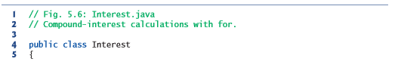

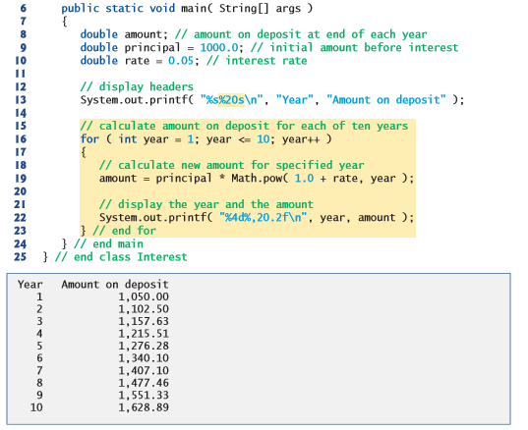

IT6425_Programming Lab Sheet 03  Hand this sheet to the lecturer for signing.  Due: 5:00 pm, Friday 1 September 2017 | Student ID: ___________________  Name: ___________________  Signature: ___________________
I have seen the tasks specified in this lab sheet running.

Signed by: _____________________________ Date: ___________________

